**Chapter 1**

**Introduction**

**1.1 Need**

1. Customer Relationship Management (CRM) is currently one of the most used notions in the articles and studies dealing with computer applications. Nowadays it is very difficult for a company to convince a customer (a potential client) with only product or price arguments because of the strong competition in almost all market areas.
2. Companies therefore reflected how to win the competition. One of the possibilities is to have the better client support – not only in the after sales phase, but also in all other phases of the client communication process, i.e. in the acquisition phase or in the loyalty phase.
3. The grade of customer’s satisfaction is the most relevant factor for the breakdown or the success of a company. Facts such as:

* One unsatisfied client has a negative influence on up to ten other clients.
* 60 % – 80 % of all decisions to buy a certain product are based on the fact that the company offers the better service/client support.
* One satisfied client positively influences up to three other potential clients.
* In the long term, five percent of the clients who have a positive image of a company can cause between 25 % and 85 % new turnover.

**1.2 Basic Concept**

CRM has been defined in numerous ways and with many descriptions. It can be defined as the art of acquiring customers and having a long-lasting relationship with them. Also, CRM is a combination of people, processes, and technology in order to understand and obtain customers for the company. It focuses on customer retention and builds up the relationship.

Using CRM, companies can maximize their interactions with customers and obtain a 360-degree vision of customers.CRM is a systematic management of relationships across all parts of the business, focusing on customers, providing long-term value for them, and increasing customer interaction. It also includes communication channels and offers of different services, thereby producing customer retention and loyalty [1].

It is an Android smart phone application, which is built taking into consideration the tourist perspective which guides the tourist to detect his location and get information of nearby places and tourist attractions. It also shows the user the optimal route and helps the user to decide the proper mode of transportation (public or private). If the route is diverted the user gets the alert message and if the user wishes to lodge a complaint against the driver he can do so. The app provides the user the proper tariff according to the distance travelled so that the vehicle driver does not charge unfair tariff.

**1.3 Applications**

* It is a user friendly application.
* It helps the tourist to trace the current location and navigate to its destination.
* As the tourist is new to the city, if the driver tries to divert the route and take the tourist through a longer route an alert message pop’s up saying the route is being diverted.
* This application guides the tourist to select optimal path.
* In case, the tourist feels the driver is charging him/her unfair charges he can also lodge a complaint against the driver.
* Application is also been provided with season wise classification.
* To help the tourist emergency numbers are also been provided.
* The tourist can also view the ratings of location and select the place they want to visit accordingly.
* The image pop up feature is also provided so that the tourist can get the clear view of the location.

**Chapter 2**

**Literature Survey**

**2.1 Customer Relationship Management Using Android Phone in Tourism**

**Authors: Nitin Khondre, Ravi Saini, Ronak Jain,**

**Sarang Suryawanshi, Bushra Quazi**

**Year: March 2014**

**Journal: International Journal of Emerging Technology and Advanced Engineering,**

**Website: www.ijetae.com (ISSN 2250-2459, ISO 9001:2008 Certified Journal, Volume 4, Issue 3, March 2014)**

Customers are the vital key for each business and company to help them to grow. So, implementing CRM important tools that will help managers and companies to increase the satisfaction and loyalty of customers more than before. Nowadays it is very difficult for a company to convince a customer with only product or price arguments because of the strong competition in almost all market areas. Mobile technology offers a high potential to significantly transform the ways how a company can interact with their customers and even with own employees. Therefore, this paper deals with the possibilities and aspects to support CRM via future mobile services.

**2.2 inGuide-Interactive Guide**

**Authors: Filipe Andre Gomes Batista, Nuno Rodrigues, and Alexandrino Goncalves**

**Year: 2009**

**Journal: (2009 3rd IEEE International Conference on Digital Ecosystems and Technologies Future Mobile CRM in Automotive and Tourist Area)**

This paper describes the inGuide modular application which provides a package management system avoiding the need for a different version of the application for each city. It also describes the geolocation technology in order to provide contextual information in a simple and interactive way. This paper describes two modes those are online mode and offline mode. We preferred online mode of GPS tracking as it gives more accurate location.

**2.3 On-line GPS Track Simplification Algorithm for Mobile Platforms**

**Author: R. Ivanov**

**Year: 2010**

**Journal: Information Technology and Control**

This paper describes an algorithm for on-line simplification of the number of points, describing a GPS track. It is offered on the base of analysis of the location of three last points.

**2.4 Overview on Android- The New Mobile Operating System**

**Author: Monika Bazard, Sonia Bhardwaj**

**Year: April, 2011**

**Journal: SGI Reflections- International Journal of Science, Technology and Management. ISSN No. 0976-2140. Volume 2, Issue 1, April, 2011**

This paper describes the Android’s history, architecture, libraries and its advantages and disadvantages in the smart phones.

**Chapter 3**

**Algorithm**

**3.1 GPS Tracking Algorithm:**

The data from the GPS receiver are processed by the program module “GPS Provider”. The module “GPS Data Dispatcher” is intended to adaptively define the moment of generation of a new track point. The time interval after which a new point is entered depends on:

* Traveled distance
* The error in the user position and
* Horizontal accuracy of GPS receiver.

GPS Provider

GPS Data

Dispatcher

Enable GPS

GPS Receiver

*Fig 3.1: Sequence to obtain the moment to enter a new track point*

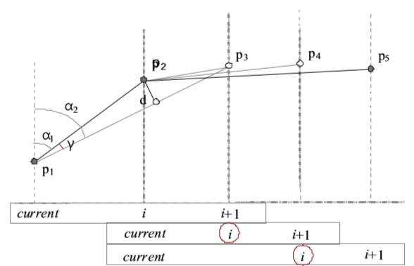

***Source (initial point)***

*Fig 3.2: Reduction of the number of points, describing a track*

The proposed tracking algorithm belongs to the distance based algorithms, but the threshold value for the distance after the passing of which a new point is entered is obtained adaptively, taking into account the current accuracy of the user’s position and the travel speed. An additional reduction of the number of points is realized by means of analysis of the position of the last 3 points generated.

The track simplification algorithm that is used belongs to perpendicular distance algorithm.

Point p1 is the last one belonging to the track. Point p2 is the last generated point. It should be defined whether point p2 belongs to the track. For that purpose the value of the angle , **- |**

The above equation is obtained. If $γ≥γ_{Th}$, then it is assumed that point p2 is a part of the track, otherwise point p2 is ignored.

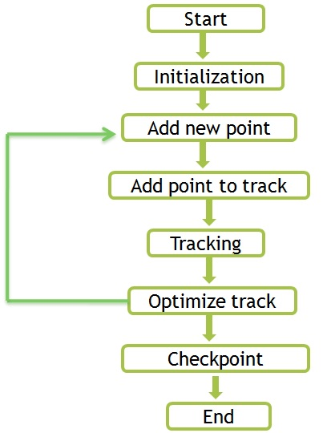

*Fig 3.3: Steps for GPS Tracking*

The module GPS Data Dispatcher is intended to inform through messages the other program modules for events from the GPS receiver. Then the system is initialized and the current point is tracked, it takes the last longitude last latitude and distance threshold after tracking the current point that is the source point the destination point has to be tracked.

Add new point realizes speed filtering, position filtering, and generation of a new point if there are necessary conditions like HDOP, and the speed and path passed with the needed ranges. After the message is receipted the GPS data is read and the reduction of the points is realized.

Through the add new pint a new point is inserted and calculated by applying the trigonometric ratios and the shortest distance is traced [2].

**Chapter 4**

**Software & Hardware Requirements**

**4.1 Hardware & Software Specifications**

## 4.1.1 Hardware Interfaces:

## System requires following hardware interfaces:

* System: Intel P4, 2.4 GHZ, 40 GB HDD for installation.
* Memory: 512 MB memory, 256 MB ram
* Project’s server side system will be windows based supporting versions windows XP onwards.

## 4.1.2 Software Interfaces:

* Eclipse 3.7 Indigo.
* Android SDK.
* Android 2.3.
* Android GPS API.
* Java Standalone HTTP Server.
* Microsoft Access DB.
* UML.

**4.2 Tools used**

**Eclipse:**

* Eclipse is an open source community whose projects building tools and frameworks are used for creating general purpose application. The most popular usage of Eclipse is as a Java development environment.
* Eclipse is an open source community, whose projects are focused on building an open development platform comprised of extensible frameworks, tools and runtimes for building, deploying and managing software across the lifecycle. The Eclipse Foundation is a not-for-profit, member supported corporation that hosts the [Eclipse projects](http://www.eclipse.org/projects) and helps cultivate both an open source community and an ecosystem of complementary products and services.
* In general, the Eclipse Foundation provides four services to the Eclipse community:

1) [IT Infrastructure](http://www.eclipse.org/org/#IT),

2) [IP Management,](http://www.eclipse.org/org/#IP Management)

3) [Development Process](http://www.eclipse.org/org/#Development) and

4) [Ecosystem Development](http://www.eclipse.org/org/#Ecosystem).

Full-time staff is associated with each of these areas and work with the greater Eclipse community to assist in meeting the needs of the stakeholders.

**JDK:**

* JDK 1.6.0_07
* Editor enhancements: Code completion hints.

**MySQL:**

* Simplified connection wizard
* MySQL 5.0
* Guided installation to JDBC driver
* Editing and deployment of stored procedures

**Chapter 5**

**Design Diagrams**

**5.1 Overview:**

**5.1.1 System Initialization**:

System gets initialized and detects the current position of the mobile handset of user.

**5.1.2 Listing Tourist Attraction:**

The source is detected using the current GPS location and the user is able to see the tourist places and attractions of that particular place/city.

**5.1.3 Tracking the Path:**

Once user has selected path, the system will track the path till user reach to the destination. If path is deviated from optimal path, then it will alert user reminding about the divergence.

**5.1.4 Fare Calculation:**

Once the destination is reached the exact fare for the journey is calculated based on different parameters stated above.

**5.1.5 Lodge Complaint:**

If driver is not agreed with the fare calculated by the system and asking for more Fare, user has the facility to lodge the complaint against the driver. The passenger can fill a small form having the details about him, the driver and his vehicle and the complaint he has against the driver. After filling all these information the user can upload this information to the central database and can send a SMS to higher authorities.

**5.1.6 Listing the Emergency Numbers:**

Based on the GPS location the emergency numbers will be fetched to help the tourist in emergency.

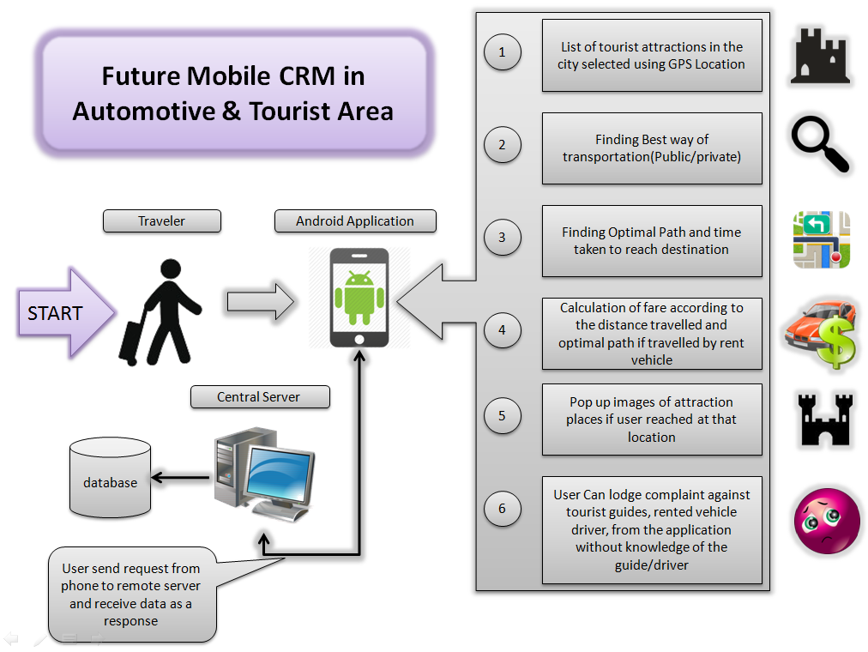

*Fig 5.1: System Architecture*

**5.2 Data Flow Diagrams:**

**5.2.1 DFD Level 0**

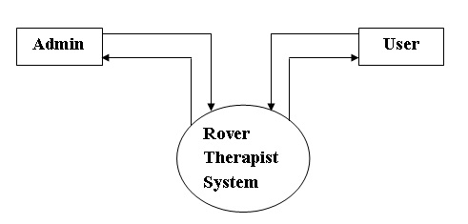

*Fig 5.2: DFD Level 0*

**5.2.2 DFD Level 1**

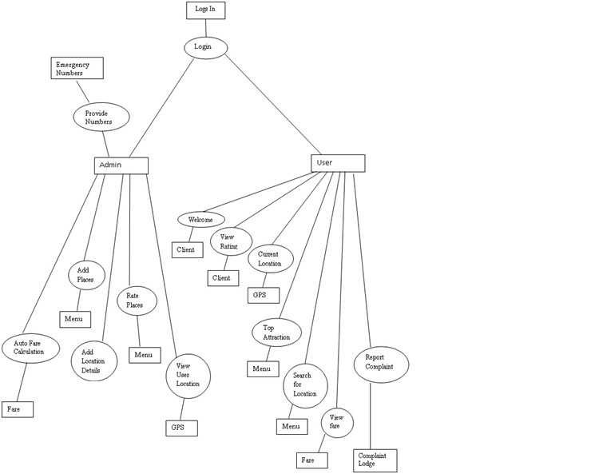

*Fig 5.3: DFD Level 1*

**5.3 ER Diagram:**

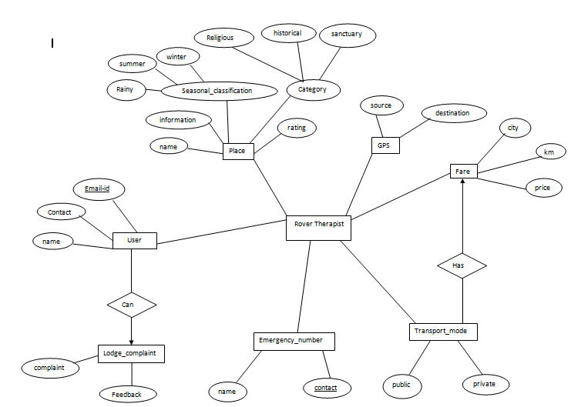

*Fig 5.4: ER Diagram*

**5.4 UML Diagrams:**

**5.4.1 Use case Diagram:** 

*Fig 5.5: Use case Diagram*

**5.4.2 Class Diagram:** 

*Fig 5.6: Class Diagram*

**5.4.3 Activity Diagram:**

*Fig 5.7 Activity Diagram*

**5.4.4 Package Diagram:**



*Fig 5.8: Package Diagram*

**5.4.5 Sequence Diagram:**



*Fig 5.9: Sequence Diagram*

**5.4.6 Communication Diagram:**

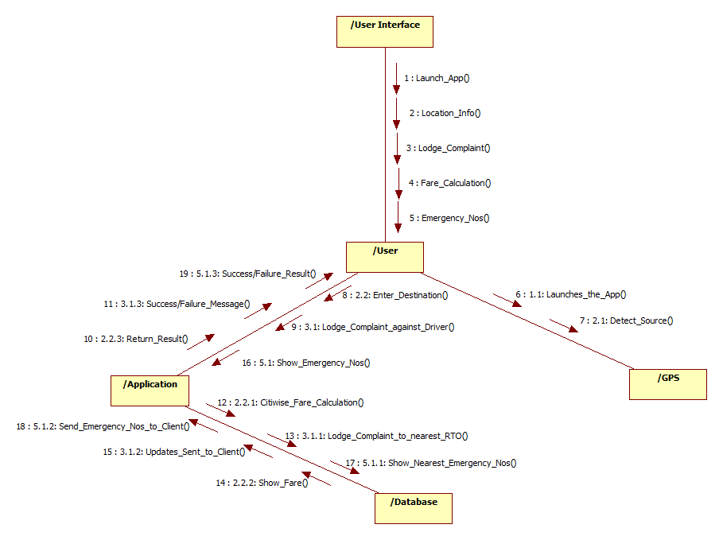

*Fig 5.10: Communication Diagram*

**5.4.7 Composite Structure Diagram:**

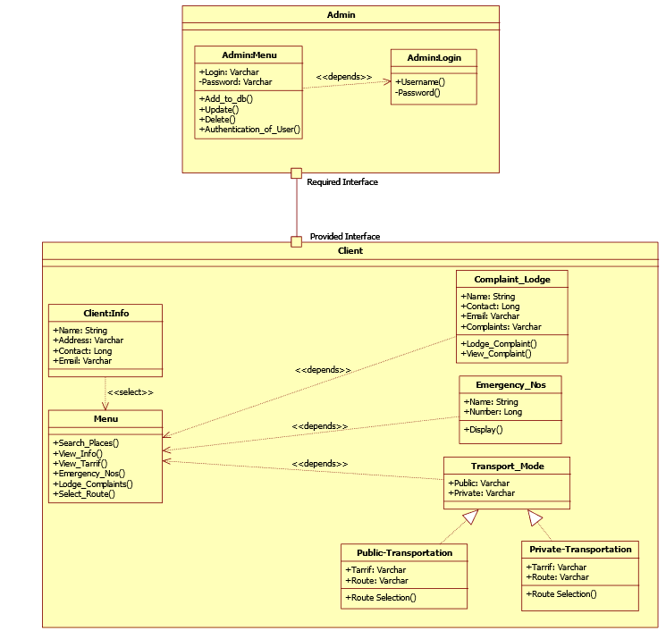

*Fig 5.11: Composite Structure Diagram*

**5.4.8 State machine Diagram:**

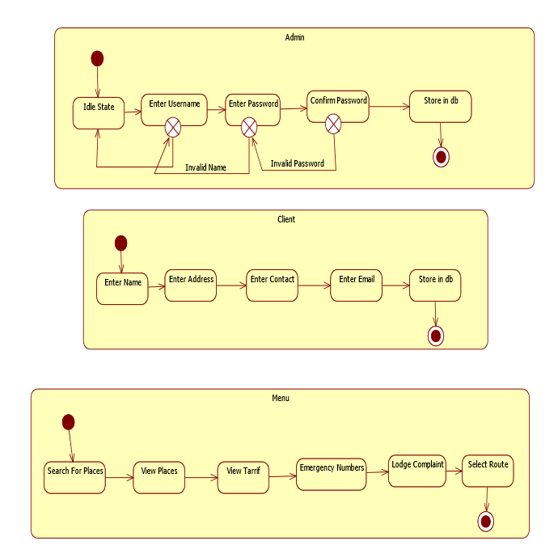

*Fig 5.12: State Machine Diagram*

**5.4.9** **Component Diagram:**



*Fig 5.13: Component Diagram*

**5.4.10 Deployment Diagram:**



*Fig 5.14: Deployment Diagram*

**Chapter 6**

**References**

[1] Nitin Khondre, Ravi Saini, Ronak Jain, Sarang Suryawanshi, Bushra Quazi, Customer Relationship Management Using Android Phone in Tourism, International Journal of Emerging Technology and Advanced Engineering.

[2] R. Ivanov On-line GPS Track Simplification Algorithm for Mobile Platforms, Information Technology and control, 2010.

[3] Filipe Andre Gomes Batista, Nuno Rodrigues, and Alexandrino Goncalves, inGuide-Interactive Guide, 2009 3rd IEEE International Conference on Digital Ecosystems and Technologies Future Mobile CRM in Automotive and Tourist Area.

[4] Monika Bazard, Sonia Bhardwaj, Overview on Android- The New Mobile Operating System, International Journal of Science, Technology and Management Volume 2, Issue 1, April, 2011.

[5] www.javatpoint.com

[6] www.develpoer.android.com